ICT220 Intermediate Website Designing

**Intermediate Website Designing**

***By;***

***Std. Names:***

***Hikmatullah Nasiri***

***&***

***Faredoon Sediqi***

***Section.: A 3rdsem ICT***

***Submitted to;***

***Mr. Parag K Rabade***

***Date Submitted: 03/9/2017***



Project Report

www.nima.edu.af

***Declaration***

I declare that the assignment entitled “Report of Advance Web Designing Assignment” is our own work and is free of any kind of plagiarism and copy.

***Table of contents***

***Acknowledgments ………………………………….……….1***

***Preface ………………….……………………………….….….2***

***HTML: …………………….…………………………….………2***

***About The Afghan Pharma: ….................…….......2***

***Codes:……………………….…………….……….….……..…3***

***Header: ……………..….………..………….……...………..3***

***Navigation:…………….………...…………..….……….…3***

***Slideshow:.……………………….………..…..…..…....…4***

***Main: …………………….………...……..………..……..…4***

***Sidebar: …………………….………......……………….….5***

***Contacts: …………………….………......…….…….…….5***

***Whole Website: ………………….….....…………6,7,8,9***

***Reference: …………………….……….....………………10***

**Acknowledgment**

Atiqullah and Hikmatullah, we both are extremely grateful to NIMA for the confidence bestowed in us.

We feel deeply honored in expressing our sincere thanks to our beloved Mr. Parag K Rabade. We would also like to thank Almighty Allah for the strength given to us and all the ICT faculty members of NIMA for their critical advices and guidance without which this report would not have been possible. We place a deep sense of gratitude to our beloved family members and friends who have been constant source of inspiration during the report work.

Head of ICT Department Lecturer of IWD

***Preface:***

Web designing is one of the most important subject to design and create the web pages. Today each organization has their own website, they create their website to stay keep in touch with their costumer. An organization, who provide services to their customers, they are also share advertisement on their site to be popular. Web designing has special popularity in the Technology market, web designer takes project from different organization, and they design and create an attractive website to them. This is the bless of web designers, who gives success for any organization.

***HTML***

HTML stands for HyperText Markup Language. It is a Language for publications in the World Wide Web, text format for HTTP (Hyper Text Transfer Technology). Its Basic language is English. It Developed in 1990 by Berners Lee. It is based very strongly on SGML (Standardized General Markup Language). It writes in the notepad ++ and editra.

It is use for presenting information in LAN / WAN, structure your text-based information Hyperlinks to reach following texts, to put images on your docs, and basic structure for all web applications, like Guestbook, Online Stores, Forums.

***About Afghan Pharma:***

This website is about a pharmacy by name of “***Afghan Pharma***”. In this project we used internal Style Sheet, external Style Sheet and JQuery to make it easy and understandable. Addition to It, we also use different HTML tags and attributes. We use Adobe Dreamweaver CC 2017 as designing tool. In this website there are 4 pages. First page is “***Home***” page. In this page, we added some slideshow. We added two types of navigations which is common in all pages. In the main of “***Home***” page there are numbers of products each product has links to page detail information of a products. We also used some links of Social Media in footer of all pages.

The second page is the “***Services***” in this page we just brought information about Afghan Pharma services and sites pictures.

The third page is the “***About*** ***Us***” in this page we declare and explain the story of this Afghan Pharma.

The last page is “***Contact Us***”, and we just created a form trough that a customer can fill and submit and we add contact number, email address, and location info.

We linked all five pages by using “a” tag and “href”.

***CODES:***

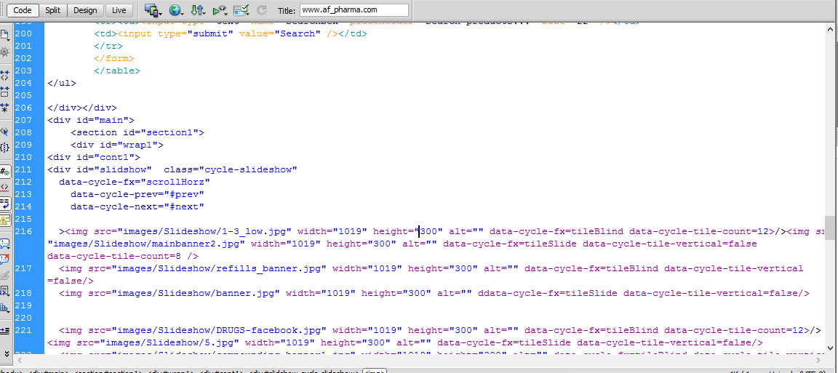All codes are available in soft copy of the project.

***Header:***

The Header of All pages’ content Afghan Pharma Logo, Title, and Background Image.

***Navigation:***

All the pages have two types of Navigation Menu; Simple navigation menu and Drop Down navigation menu which contents 4 page’s links.

**Simple Navigation** also contents a search box.

**Drop Down Menu**



***Slideshow:***

In the slideshow section we added some pictures of medicine and drugs using JQuery to slide the picture with different effects and two buttons to navigate the images previous and next buttons by using arrows images.

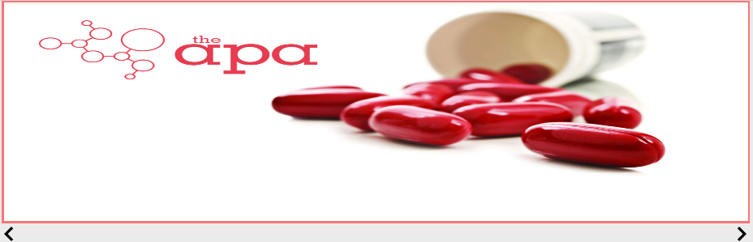

***Main***:

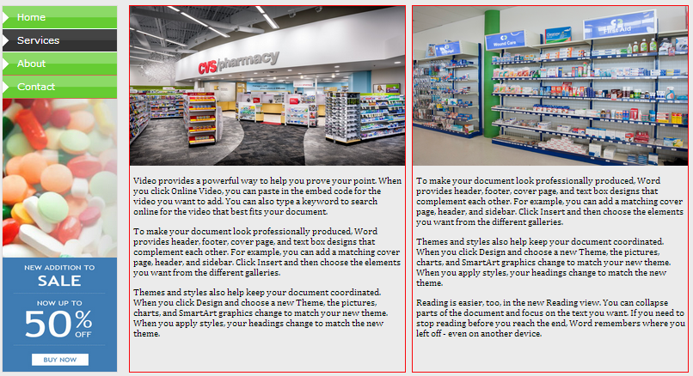In the main section of the website we added some sections and important issues for the viewers of my website, which can attract the viewer or the visitor to be active or be a member of my website. Main section in each page is different.

***Products Page:***

In this page we add detail information about the clicked product.

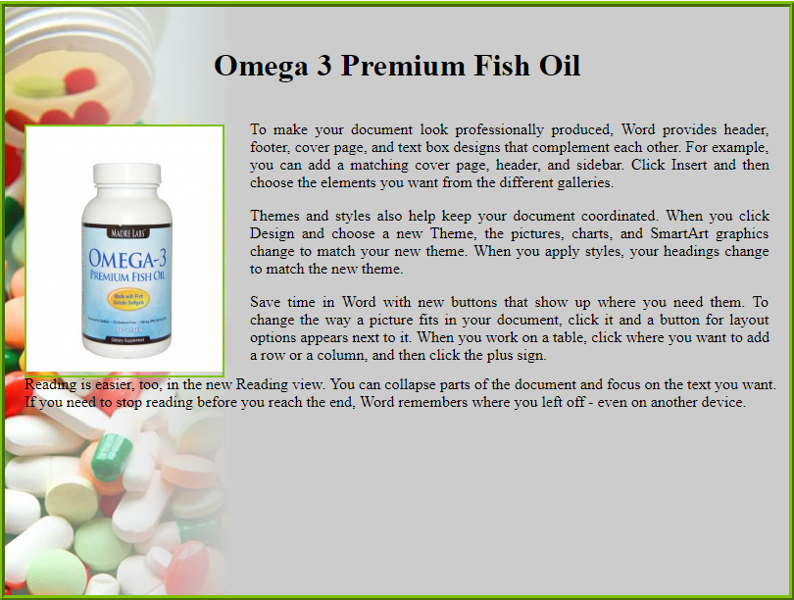

***Contacts:***

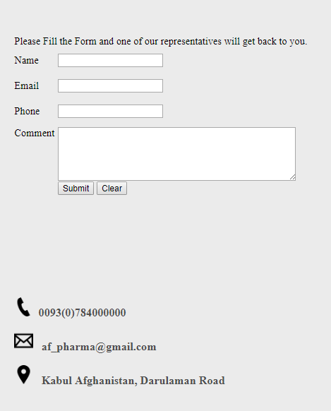In this section for help or any other urgent work we used to add email, current address, contact number and a form for feedback purpose to the Afghan Pharma customers.

***Home***

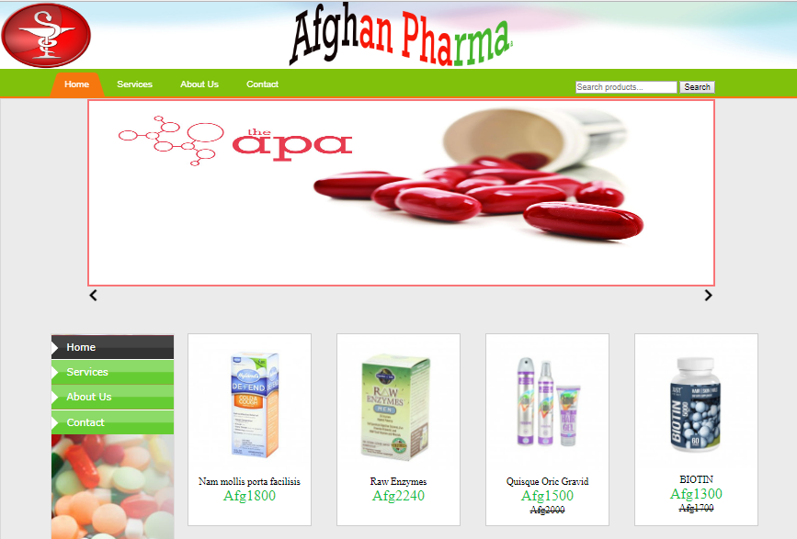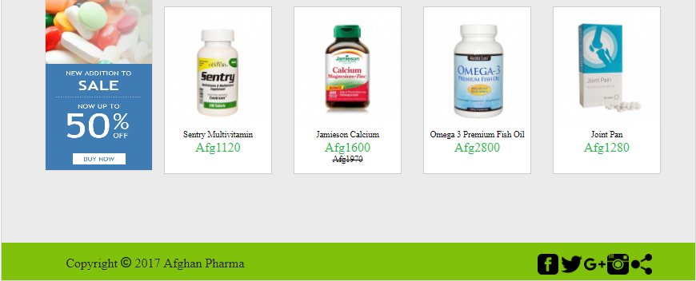

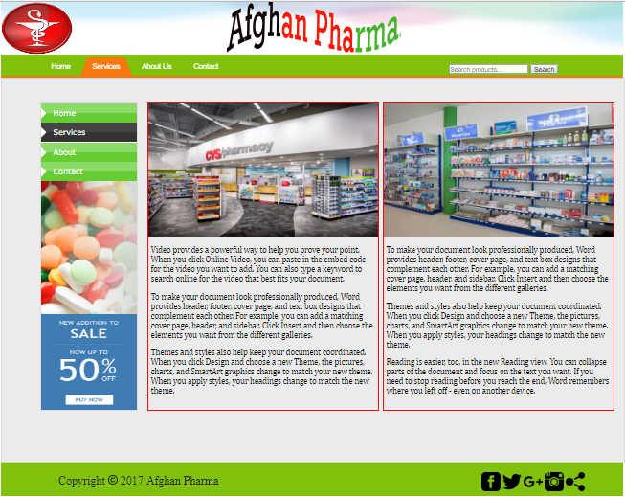***Services***

***About Us***

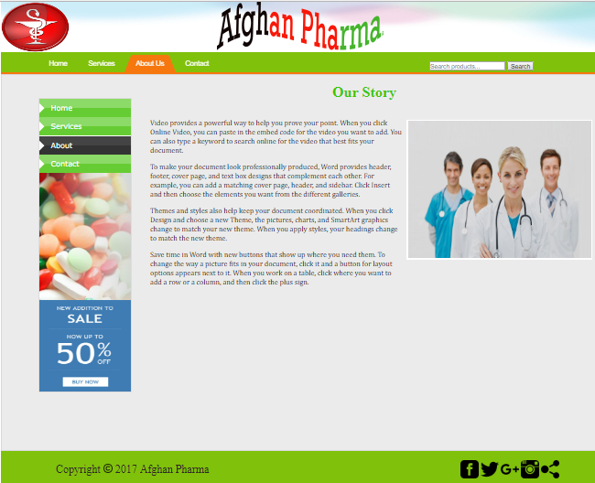

***Contact Us***

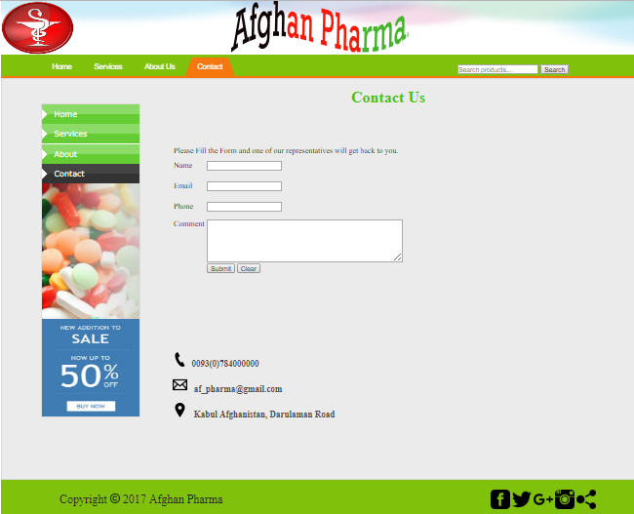

***Product Page:***

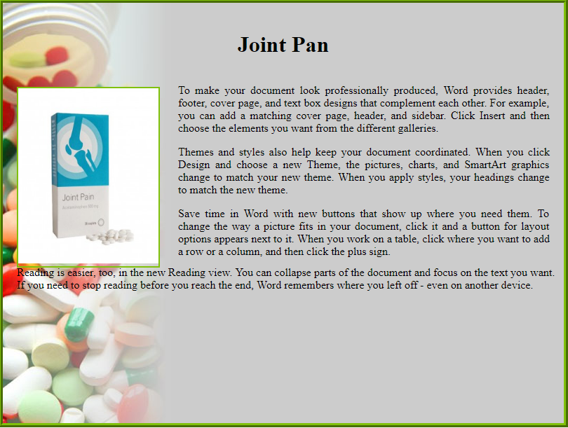

***References***

* Sir Parag Rabadi Instruction and Videos Tutorials
* Sir Rooh_ul_amins Instruction Videos Tutorials
* Beginning HTML, XHTML, CSS Books.
* The CSS Anthology
* Color. Adobe. come
* Lecture videos and YouTube - video learning of “WEB DESIGNING”

***Thanks from***

Our dear and beloved Teachers Parag Rabadi and Former Instructor Mr. Rooh-ul-Amin Mashwani.